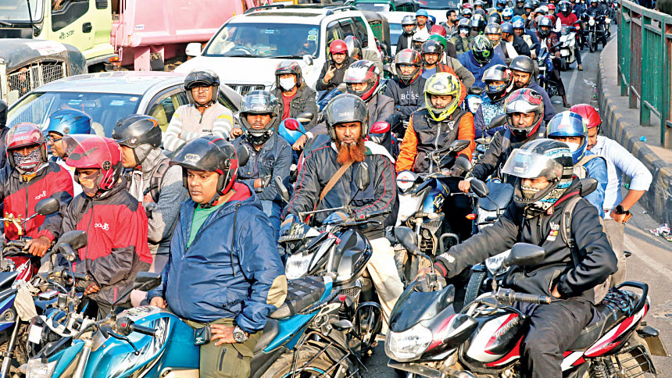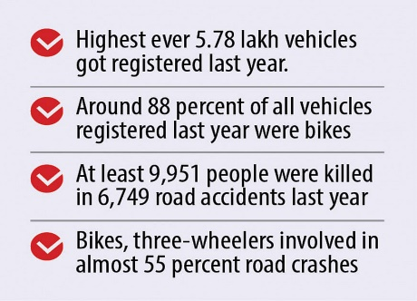

Representational image. Photo: Prabir Das

# Documents of 30,000 clients go missing from RAJUK server

Around 30,000 clients' documents seeking permission for construction of buildings have been lost from the server of Rajdhani Unnayan Kartipakkha (RAJUK).

The city building authorities came to know about the incident on 6 December, but RAJUK is still in dark as to whether this happened due to technical glitch or anyone did it intentionally.

The authorities are yet to form a probe committee to investigate the incident in over three weeks, raising questions over the RAJUK’s sincerity to unearth the reason behind it.

Loss of these documents may also spawn corruption. For example, many people want to take bank loans keeping buildings as mortgage. Bank authorities in such case send letter to RAJUK for verification. With the loss of the document, such clients would face trouble getting bank loans as RAJUK would not be able to verify the documents.

Also, clients would be able to temper the design approved by the RAJUK. The RAJUK authorities would not be able to do much to prevent such wrongdoings since they have the design to challenge any forged documents. Also the RAJUK authorities would not be able to do anything if anyone constructs buildings beyond approved height.

"Unregulated growth in vehicle numbers, particularly motorcycles and three-wheelers, are directly linked to the rise in road crashes. However, this is not the single reason behind road crashes,".

Road Transport and Highways Division Secretary ABM Amin Ullah Nuri, however, said they don't believe 10,000 deaths on roads, as mentioned by Jatri Kalyan Samity, is correct.

**Small vehicles shoot up,so do accidents**

**A sharp and unregulated growth of vehicles, especially motorcycles and three-wheelers, over the last few years has resulted in a spike in the numbers of road crashes and casualties.**

A total of 5.78 lakh vehicles were registered with Bangladesh Road Transport Authority (BRTA) last year, the highest in a single year and 29.91 percent higher than that of 2021.

Motorbikes and three-wheelers were involved in almost 55 percent of the 6,749 road crashes recorded last year.

**Exports hit record on Christmas cheer**

The export receipts from apparel shipments are high because of the increase in unit price on the back of the elevated price levels for raw materials like yarn and fabrics in the global market, said Faruque Hassan, president of the Bangladesh Garment Manufacturers and Exporters Association, the garment exporters' platform.

The same garment item that sold for $10 during the holiday season last year cost $13-14 this year.

Moreover, Bangladesh also started exporting high-end value-added garment items for which the international retailers and brands are also paying better prices, Hassan said.

Exports fetched a record $5.37 billion in December as consumer spending centring on Christmas in the Western world returned in full swing after two pandemic holiday seasons marked by health fears and supply shortages. Last month's receipts take 2022's export earnings to a record $54.7 billion, up 23.7 percent year-on-year, according to data from the Export Promotion Bureau. As always, garments accounted for about 84 percent of the export receipts, bringing home $4.67 billion in December.

THEDAILYSTAR.COM THURSDAY 06 JUNE,2024 YOUR DAILY FAVOURITE SINCE 1968